**EXPERIMENT 9:** *To use Apache Pig and implement group by, order by, filter and join operations on databases inside HDFS.*

**Name: Adwait Purao**

**UID : 2021300101**

**Division: COMPS B**

1. **Start Pig in Local Mode:**
   1. **Command:**

| pig -x local |
| --- |



1. **Load data into Apache Pig:**
   1. **Command:**

| cricketers_data = LOAD 'file:///home/hadoop/Desktop/Pig/cricketers_data.txt' USING PigStorage(',') AS (player_id:int, name:chararray, team:chararray, score:int);  dump cricketers_data; |
| --- |

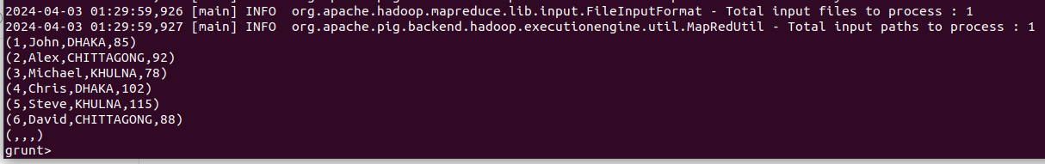

1. **Load data into Apache Pig:**
   1. **Command:**

| team_data = LOAD 'file:///home/hadoop/Desktop/Pig/team_data.txt' USING PigStorage(',') AS (team:chararray, coach:chararray);  dump team_data; |
| --- |

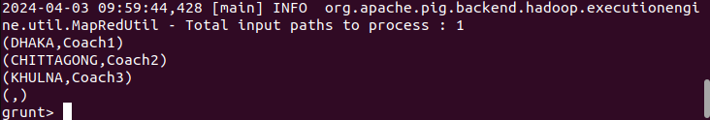

1. **Group By: To group the data by team:**
   1. **Command:**

| grouped_data = GROUP cricketers_data BY team;  dump grouped_data; |
| --- |

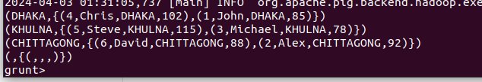

1. **Order By: To order the data by score:**
   1. **Command:**

| ordered_data = ORDER cricketers_data BY score DESC;  dump ordered_data; |
| --- |

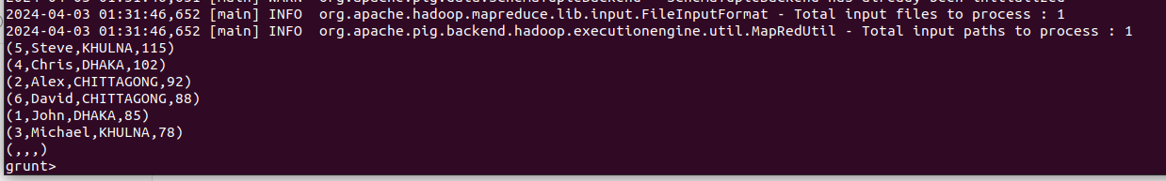

1. **Filter: To filter the data for a specific team, say KHULNA**
   1. **Command:**

| filtered_data = FILTER cricketers_data BY team == 'KHULNA';  dump filtered_data; |
| --- |



1. **Join: To join two datasets,on the basis of a common attribute.** 
   1. **Command:**

| joined_data = JOIN cricketers_data BY team, team_data BY team;  dump joined_data; |
| --- |

